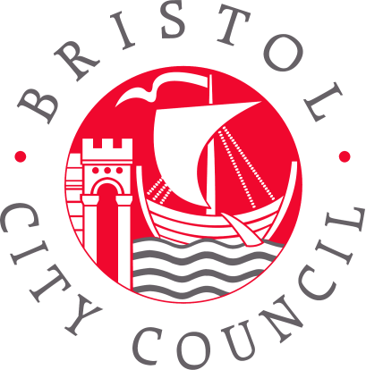

 |  | Reply to | Mayor’s Office
 |  | E-mail | mayor@bristol.gov.uk
 |  | Date | 16 September 2016

Dear parent

Pupil Premium – Note from the Mayor and Councillor Claire Hiscott about this important funding

We hope your child is settling well into the new school year!

We’re writing to you to highlight a really important part of the funding available for your child's education – the Pupil Premium.

All primary pupils of parents receiving certain benefits are entitled to this extra funding. It aims to help pupils from low income families get the best start in life. The money – around £1320 per child – goes directly to the school. It pays for things like school trips, breakfast clubs, or additional teachers and assistants to provide extra support and 1 to 1 tutoring. Your child’s school reports on how they spend the money on its website.

The money makes a really important difference to schools and the eligible pupils!

Since 2014 all children attending school in Reception, Year 1 and Year 2, have been entitled to free school meals. However, not all parents and carers of eligible children know that they still need to sign up for the Pupil Premium. If they don’t, the school loses out on getting this really important source of income.

Please read the information below, and if you think your child may be eligible please contact your school for more information on how to apply. Children from Reception to Year 6 may be eligible.

Note: The funding arrangements for children who are looked after/in care or adopted from care are different. Please contact the Hope Virtual School for details: 0117 9036282 or go to www.bristol.gov.uk and search for ‘Hope Virtual School’.

Is your child eligible for Pupil Premium?
In order for the school to receive the Pupil Premium funding, a parent/carer must be claiming one of the following benefits:
- Income Support
- Income-based Jobseeker’s Allowance
- Income-related Employment and Support Allowance
- Support under Part 6 of the Immigration and Asylum Act 1999
- The guaranteed element of State Pension Credit
- Child Tax Credit (as long as you’re not also entitled to Working Tax Credit and have an annual gross income of no more than £16,190)
- Working Tax Credit run-on (paid for four weeks after you stop qualifying for Working Tax Credit)
- Universal Credit.

Next steps:

Once you’ve contacted your school and filled in the form, we can check whether your child is eligible, via the Department of Education. We are not given any other information about you or your child. You will receive a letter from us with the result of your application.
If your child is eligible for the funding, your child’s school will look after everything and be in touch with you with further information.

If your child was not eligible this time round, please apply again in future. Changes in your circumstances may mean that your application could be successful next time.
There is more information on the Bristol City Council website: https://www.bristol.gov.uk/schools-learning-early-years/free-school-meals
(You can also find the dedicated webpage by searching for ‘Pupil Premium’ on www.bristol.gov.uk)

We hope you have found this information helpful. We want the best for every child in Bristol.

Yours faithfully

Marvin Rees, Mayor and Councillor Claire Hiscott, Cabinet Member for Education and Skills

Contact information:
Free School Meals
Bristol City Council, PO Box 3176, Bristol, BS3 9FS
Email: free.school.meals@bristol.gov.uk
Tel: 0117 903 7990

