Term 1 2024 – All About Me and Settling into the Nursery Routine

Week 1  2.9.24 | Week 2  9.9.24 | Week 3  16.9.24 | Week 4  23.9.24 | Week 5  30.9.24  Black History Month | Week 6  7.10.24 | Week 7  14.10.24 | Week 8  21.10.24  Diwali after the holidays
Home Visits  Stay and Play sessions  Weeks 1-3 - Nursery Baseline |  | Discovery Focus:  Personal, Social and Emotional Development – Making friends/new school/learning routines and making links.  Find ways of managing transitions, for example from their parent to their key person.  Play with increasing confidence on their own and with other children, because they know their key person is nearby and available.  ntroduce daily teeth cleaning.  Understanding of the World: Routines + All about me. (my Nursery, my family, my body, my birthday)  Expressive Arts and Design: learning how to use the class and garden resources. Teaching of what resources are for and what we do with them.  Literacy Focus: Core books    Rhyme of the week:  Heads, Shoulders, Knees and Toes  Twinkle, Twinkle  Rolly, Polly  Literacy/Physical Development – Squiggle while you wiggle – fine motor development.  Developing core muscle strength – tummy time “writing,” Developing anti clockwise within rotator cuff muscles - large circles, developing into fine motor actions. Introduction of large equipment.  Develop manipulation and control.  Explore different materials and tools.  Continue to develop their movement, balancing, riding (scooters, trikes and bikes) and ball skills.  Go up steps and stairs, or climb up apparatus, using alternate feet.  Learning the skills to climb the outdoor equipment.  Phonics: Name games and listening skills.  Oracy Focus:  Talk Boost book: 1 – Attention and Listening games  Maths Focus: White Rose Maths  Getting to know you counting rhymes, daily routines.  - More than, fewer than, same.  - Explore and build with shapes and objects. |  |  | Discovery Focus:  Personal, Social and Emotional Development – Making friends/new school/learning routines and making links.  Find ways to calm themselves, through being calmed and comforted by their key person.  Engage with others through gestures, gaze and talk. Use that engagement to achieve a goal. For example, gesture towards their cup to say they want a drink.  Develop friendships with other children.  Understanding of the World: Routines + All about me. (my Nursery, my family, my body, my birthday)  Introduce SPECIAL BOXES – children collect a few items from home to show and tell.  Autumn – begin forest school sessions  Explore and respond to different natural phenomena in their setting and on trips.  Expressive Arts and Design:  Learning how to use the class and garden resources.  Teaching of what resources are for and what we do with them.  Literacy Focus: Core books  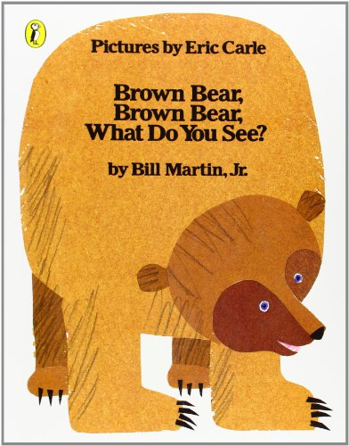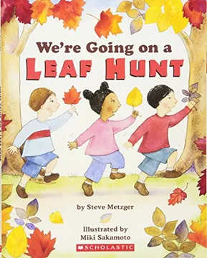  Rhyme of the week:  Humpty Dumpty  All the leaves are falling  Incy Wincy Spider  Literacy/Physical Development – Squiggle while you wiggle – fine motor development.  Developing core muscle strength – tummy time “writing,” Developing anti clockwise within rotator cuff muscles - large circles, developing into fine motor actions. Introduction of large equipment.  Develop manipulation and control.  Explore different materials and tools.  Continue to develop their movement, balancing, riding (scooters, trikes and bikes) and ball skills. Go up steps and stairs, or climb up apparatus, using alternate feet.  Learning the skills to use the outdoor equipment safely.  Phonics: To develop children’s listening skills and awareness of sounds in the environment. Environmental sounds.  Oracy Focus:  Talk Boost book: 2 Big and Little  Maths Focus: White Rose Maths  Getting to know you counting rhymes, daily routines.  - Patterns  - Counting 1 – hear and say number names,  - Counting 2 – begin to order number names.

