Term 4 2025

Week 1  24.2.25  Inset Day Monday | Week 2  3.3.25  Trip to Grimsbury Farm  Tuesday and Thursday  Start of Ramadan | Week 3  10.3.25 | Week 4  17.3.25 | Week 5  24.3.25  A baby and their parent will come into visit the children to learn more about how to care for a baby. | Week 6  31.3.25  Easter Celebrations  Eid Celebrations
Discovery Focus: Farm Life  PSED – The children will continue to explore feelings through personal experiences, stories, puppets and role play.  Children will learn understand and label the feeling angry/cross.  Children will learn that some actions can hurt or harm others.  The children will begin to understand how to be healthy – food water, exercise and sleep.  Understanding of the World: Farm Life  Children will explore a farm.  Children will describe similarities and differences between their immediate environment and a Farm.  The children will learn the names of farm animals and their babies.  The children will learn about where our food comes from.  They will learn that some animals are for food and how some fruit and vegetables are grown. The will learn how food ends up in our supermarkets for us to buy.  Forest School – Observing the Signs of Spring  The Nursery will continue to learn about different celebrations and share personal experiences: This is the start of Ramadan.  Expressive Arts and Design:  Observational paintings – spring flowers  The children will learn how to mix a primary colour of the correct consistency using powder paint independently With some prompting use the water, sponge, paint, pallet sequence.  Play dough and Clay  The children will be learning how to make a range of marks in malleable materials using a range of resources, pressing coins or pebbles into Playdough.  Literacy Focus: Core books  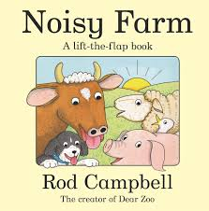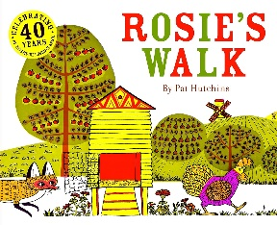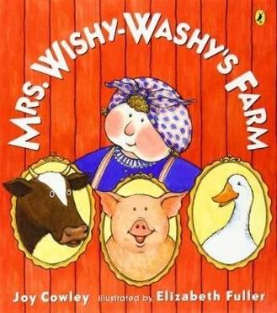  Learn to retell a simple story.  Character  Invention/imagination/making up our own stories.  Turn pages of books independently.  Act out fairy tales using key story telling words  Describe settings in stories.  Join in with key phrases in stories and rhymes.  To know the difference between writing and reading.  Know that ‘writing’ means something.  Rhyme of the week:  Sing a large repertoire of songs.  Old Macdonald had a farm  5 little ducks  Mary had a little Lamb  Physical Development  We will be playing lots of games to help us gain increasing control of our bodies when running, and jumping.  Fine Motor –  We will be learning how to hold a pair of scissors using the thumbs up position.  We will develop counting and fine motor skills by learning to skilfully Build a tower of up to 10 bricks using Duplo or wooden construction  Phonics:  Environmental Sounds  Children will learn to describe the sounds around them.  Instrumental Sounds  The children will learn to identify the sounds and name the instruments. To identify how to change the sound of an instrument.  Body Percussion  Children will learn to make their own body percussion patterns and rhythms.  Rhythm and Rhyme  Children will learn to recognise some simple rhyming words.  Children will learn to clap the syllables in words.  Oracy/Speaking and Listening Focus:  Talk Boost book: 6  Maths Focus: White Rose Maths  Continue to learn:  Sorting  Counting 1  Counting 2  Number 3  The children will learn to:  Subitise 3- children will learn to recognise 3 dots.  Continue to recognise 3 objects without counting them.  Counting 3- to count 3 objects.  Numeral 3- what is 3 and what does it represent.  To recognise triangles-a shape with 3 sides.  Space shape and measure  Exploring Position and Routes.  The children will learn to:  Respond to simple language of position.  Arrange blocks in a chosen position.  Select shapes for a space.  Recognise when 2 objects are the same shape.  Explore and describe shapes and objects.  Sort shapes and objects into simple categories.  Counting 4  The children will learn to:  Count 4 objects.  Recognise the numeral 4 and match to the correct quantity.  Recognise squares and rectangles and simple properties. |  |  | Discovery Focus: Babies – changing me and The Life Cycle of a Butterfly  PSED – The children will continue to explore feelings through personal experiences, stories, puppets and role play.  Children will learn understand and label the feeling scared.  The children will learn how to care for class pets, chicks and caterpillars/butterflies.  Understanding of the World: Life Cycles  The children will look at how we change over time. From when we were born to present day.  Children will be learning all about the life cycle of a caterpillar and a chick.  Forest School – Observing the signs of Spring  The Nursery will continue to learn about different celebrations and share personal experiences: This is the start of Ramadan.  Expressive Arts and Design:  Observational Painting of healthy fruit and Veg.  Recognise and name some secondary colours: Orange, purple, green. With minimal reminders, uses the water, sponge, paint,  pallet sequence.  The children will be making toys for their baby brothers and sisters and any babies that we have come into visit us.  They will be learning how to use glue spreaders and PVA glue  Independently.  .  Literacy Focus: Core books  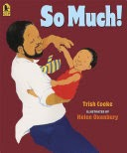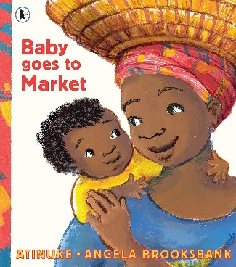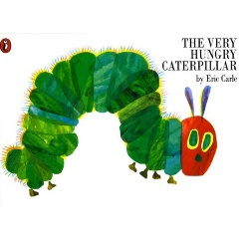  Learn to retell a simple story  Setting  Invention/imagination/making up our own stories.  To learn about traditional tales and what a traditional tale is. To learn how to tell a story and how we can change an ending to a story.  Write name at every opportunity – as label for models, on any work on paper.  Practice making marks and patterns using pens, pencils, crayons, chalks, paints, sand, dough.  Rhyme of the week:  Sing a large repertoire of songs.  Rock a bye baby  Miss Polly had a Dolly  Caterpillar Song  Physical Development  We will be playing lots of games to help us gain increasing control of our bodies when standing on one leg.  Fine Motor-  We will be learning how to make snips in paper with scissors.  Phonics:  Instrumental Sounds  Children will learn to talk about and describe the sounds each instrument makes. To follow instructions on how to change the sound.  Rhythm and Rhyme  The children will develop more of an understanding of rhyme and begin to make up their own rhyming words.  Alliteration  The children will learn how to select an object with a given initial sound.  They will learn to identify the initial sounds in words.  Oral Blending and Segmenting  The children will practice hearing and saying the initial sounds in words.  They will learn that words can be broken down into phonemes.  Children will learn to select the correct object when words are broken down into phonemes.  Oracy/Speaking and Listening Focus:  Talk Boost book: 7  Maths Focus: White Rose Maths  Continue to learn:  Counting 3  Counting 4  2d shape  Tall and Short  The children will learn to:  Compare the heights of different objects using the words tall and short.  Compare the lengths of different objects using the words long or short.  Counting 5  The children will learn:  How to count 5 objects.  The Numeral 5.  The composition of 5.  2d shape  The children will learn:  To recognise squares and rectangles and to talk about their properties.  Mass – introducing balance scales  The children are introduced to balance scales.  The children will learn:  What happens when they put different objects in them.  They will investigate and learn the words heavy and light.

