Term 2 2025 –

Week 1  Wellcomm  Speech and Language Assessments | Week 2 | Week 3 | Week 4 | Week 5 | Week 6  Winter Performances | Week 7  Christmas Showcase  Visit from Santa
Discovery Focus:  Personal, Social and Emotional Development– Managing feelings and behaviour, sustaining concentration, sharing and caring.  Increasing independence.  Understanding of the World:  Space, light and dark, nocturnal animals. Winter. Diwali, Bonfire Night.  To begin to understand the difference between light and dark?  To begin to understand what light is and identify sources of light.  To begin to understand what darkness is and how it is the opposite of light.  To begin to understand that light travels through transparent materials.  To begin to understand that shadows are created by light and solid objects.  Expressive Arts and Design:  Developing imagination/ exploration of media.  Exploring the sounds of different instruments  Small world - Learn how to use the resources and how to make up stories and play together with them.  Literacy Focus: Core books  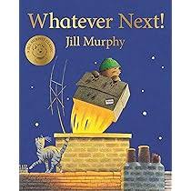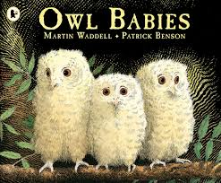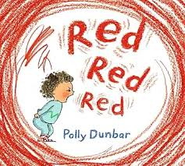  Learn to retell a simple story.  Character  Invention/imagination/making up our own stories.  To develop focus when listening to stories and to join in with repeated phrases.  Rhyme of the week:  Zoom, Zoom, Zoom  If your happy and you know it  Round and Round the Garden  Physical Development  Squiggle while you wiggle – fine motor development  To put on our own coats – with zip  Exploring mark making as a sensory experience.  Making marks in different textures.  To make marks with growing confidence with a variety of tools.  Developing anti clockwise action in dominant hand.  Mark making with different media  Name recognition  Gross motor – jumping, pushing and moving large equipment safely.  Phonics: Phase 1 and name games  Environmental Sounds - Children will learn to name the sounds around them.  Instrumental Sounds - The children will learn to explore instruments and the sounds that they make.  Body Percussion - Children will learn to join in with body percussion patterns.  Voice Sounds -The children will learn to recognise different voice sounds. For example a friend who is hiding.  Oracy/Speaking and Listening Focus:  Talk Boost book: 2  Action words  Understanding sentences with 2 key words  Putting 2 early words together  Maths Focus: White Rose Maths  - Sorting  - Number 1  - Number 2 Subitising |  |  | Discovery Focus:  Personal, Social and Emotional Development– Managing feelings and behaviour, sustaining concentration, sharing and caring.  Increasing independence.  Understanding of the World:  Who are the people in the community who help us?  Christianity: Why do Christians perform nativity plays at Christmas?  Expressive Arts and Design:  Singing and using instruments ready for the Winter performance.  Small world - Learn how to use the resources and how to make up stories and play together with them.  Literacy Focus: Core books  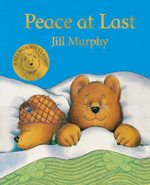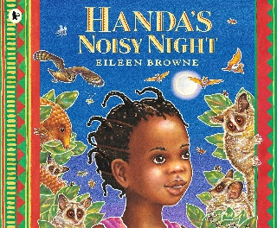 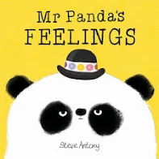Learn to retell a simple story  Setting  Invention/imagination/making up our own stories.  We will develop our focus when listening to the stories and join in with repeated phrases.  Rhyme of the week:  This is the way we….  Sleeping Bunnies  The Wheels on the Bus  Physical Development  Squiggle while you wiggle – fine motor development  To put on our own coats – with zip  Exploring mark making as a sensory experience.  Making marks in different textures.  To make marks with growing confidence with a variety of tools.  Developing anti clockwise action in dominant hand.  Gross motor – jumping, pushing and moving large equipment safely.  Phonics: Phase 1 and name games  Environmental Sounds - Children will learn to name the sounds around them.  Instrumental Sounds - The children will learn to explore instruments and the sounds that they make.  Body Percussion - Children will learn to join in with body percussion patterns.  Voice Sounds -The children will learn to recognise different voice sounds. For example a friend who is hiding.  Oracy/Speaking and Listening Focus:  Talk Boost book: 3  Using 1 word to describe an action  Remembering 2 things at a time  Understanding/using simple describing words  Maths Focus: White Rose Maths  - 2d shape  - Number 2  - Pattern – explore repeats |  |  | 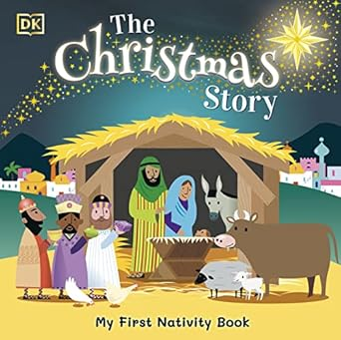  CONSOLIDATION

