Term 3 2025–

Week 1  6.1.25  New children start | Week 2  13.1.25 | Week 3  20.1.25  Trip into our local environment to look at familiar buildings. | Week 4  27.1.25  Lunar New Year | Week 5  3.2.25 | Week 6  10.2.25  Valentines Day  Inset Day – Friday  Trip to the Library
Discovery Focus: Traditional Tales and Where I live  PSED Our Class Rules and Friendship  Self-Regulation, Managing Self and Building Relationships  Play with one or more other children, extending and elaborating play ideas.  Understanding of the World:  Forest School – Winter  Explore natural materials, indoors and outside.  Use all their senses in hands-on exploration of natural materials. Explore collections of materials with similar and/or different properties.  Talk about what they see, using a wide vocabulary.  Continue to learn about different celebrations and share personal experiences: Birthdays, New Years, Lunar New Year.  Begin to understand know that there are school days and non-school days and what happens on different days. Eg children share weekend news.  Following a recipe and making gingerbread Men. To understand how materials/the ingredients change.  Expressive Arts and Design:  Take part in simple pretend play, using an object to represent something else even though they are not similar.  Begin to develop complex stories using small world equipment like animal sets, dolls and dolls houses, etc.  Role Play Learn to act out collaborative narratives using costumes, masks and props.  Small world - Learn how to use the resources and how to make up stories and play together with them.  Literacy Focus: Core books  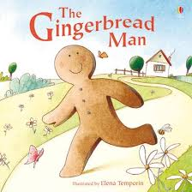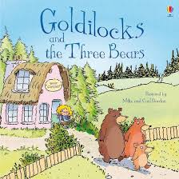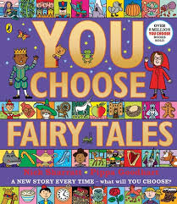  Learn to retell a simple story.  Character  Invention/imagination/making up our own stories.  Turn pages of books independently.  Act out fairy tales using key story telling words  Describe settings in stories.  Join in with key phrases in stories and rhymes.  To know the difference between writing and reading.  Know that ‘writing’ means something.  Rhyme of the week:  Sing a large repertoire of songs.  See the Bunnies Sleeping  Miss Polly  Jelly on a plate  Physical Development  Squiggle while you wiggle and Finger Gym– fine motor development  Learn about oral hygiene and brushing teeth.  Try and taste different foods.  Jumping - Practice pushing feet down into the ground to jump with increased height and distance.  Climbing - Develop balance and control when climbing and on equipment.  Fine Motor: Construct with a variety of small materials and tools.  Develop correct pencil grip and begin to form letters and scissor skills.  Phonics: Talking about sounds (developing vocabulary and language comprehension) Playing with initial sounds, can you hear and say initial sounds in words.  Oracy/Speaking and Listening Focus:  Talk Boost book: 4  Show understanding of prepositions, such as ‘under,’ ‘on top’ ‘behind’ by carrying out an action or selecting correct picture.  Maths Focus: White Rose Maths  Subitising 3, Counting 3, Composition of 3  Triangles  Move and Label 123  Rhymes  When Goldilocks Went to the House of the Bears  1, 2, 3, 4, 5, Once I Caught a Fish Alive |  |  | Discovery Focus: Traditional Tales and where I live  PSED – Class Rules and Feelings  To find solutions to conflicts and rivalries. For example, accepting that not everyone can be Spider-Man in the game, and suggesting other ideas.  Understanding of the World:  Forest School – Winter  Explore materials with different properties.  Make connections between the features of their family and other families.  Cooking porridge and describing the different tastes. Observing the changes during and after cooking.  Den making – exploring materials. How could we make the strongest house.  or the tallest.  Lunar New Year and cooking noodles  Expressive Arts and Design:  Join different materials and explore different textures.  3D work  Experiment with materials to make homes and buildings. Building and constructing homes and buildings. (three little pigs) Making bridges for the goats.  Investigate joining materials together. Glue, tape, pegs.  Learn how to use scissors.  Literacy Focus: Core books  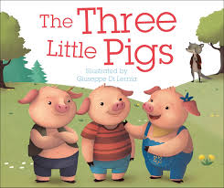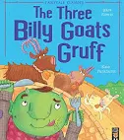  Learn to retell a simple story  Setting  Invention/imagination/making up our own stories.  To learn about traditional tales and what a traditional tale is. To learn how to tell a story and how we can change an ending to a story.  Write name at every opportunity – as label for models, on any work on paper.  Practice making marks and patterns using pens, pencils, crayons, chalks, paints, sand, dough.  Rhyme of the week:  Sing a large repertoire of songs.  Princess Song  Horsie Horsie  The Grand Old Duke of York  Physical Development  Squiggle while you wiggle – fine motor development  Finger Gym  Learn about oral hygiene and brushing teeth.  Try and taste different foods.  Develop develop spatial awareness.  Explore ways of travelling under, over and through equipment emphasising body shape e.g. wide, tall, small, curling and stretching  Fine Motor: Construct with a variety of small materials and tools. Refine small hand movements by practising using small equipment e.g. pegs on a pegboard, tweezers etc.  Develop correct pencil grip and begin to form letters and scissor skills.  Phonics: Talking about sounds (developing vocabulary and language comprehension) Playing with initial sounds, can you hear and say initial sounds in words.  Oracy/Speaking and Listening Focus:  Talk Boost book: 5  Use talk to connect ideas, explain what is happening and anticipate what might happen next, recall and relive past experiences.  Maths Focus: White Rose Maths  Books • Where’s Spot? by Eric Hill • Everyone Hide From Wibbly Pig by Mick Inkpen • Where, Oh Where, is Rosie’s Chick? by Pat Hutchins  Shape, Space and Measure  Exploring position and routes  Counting 4, Numeral 4, Composition of 4  squares and rectangles

